Z80 Playground v1.2

*(Instructions updated 7th January 2021)*

Hello!

Thank you for buying a Z80 Playground! I hope that you get as much enjoyment from using it as I have got from designing and building it.

Let’s get it set up on your computer. I’m assuming you have a Windows 10 PC. If not you may need to deviate from these instructions a little.

1. Make sure that all the chips are still in their sockets. Who knows what this tiny computer has endured in the mail? Please press them all in securely. In the event that any have come right out, the convention I have used is that all the chips have the indentation that marks the top of the chip either pointing to the left or to the top. If in doubt, here is a photo:  
   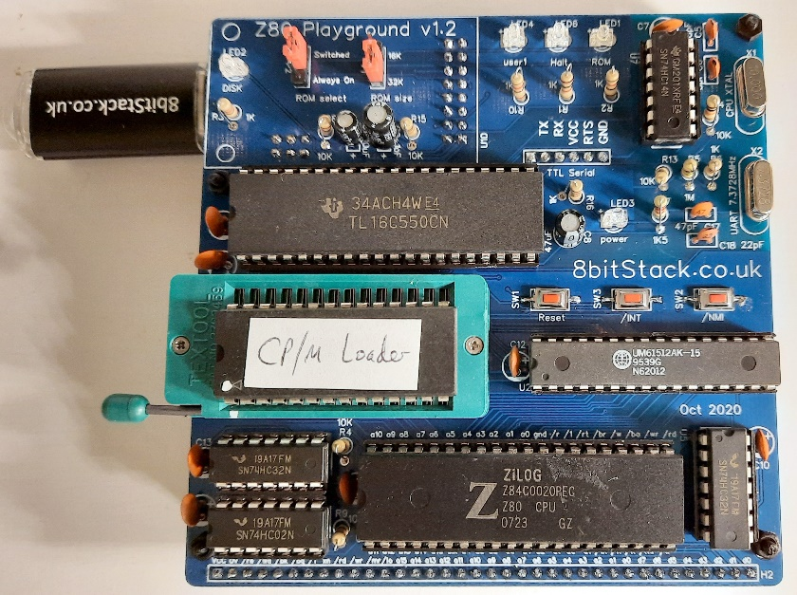
2. Especially make sure that the EEPROM (marked “CP/M Loader”) is inserted correctly and that the socket is locked down. The level points **up** when it is unlocked. Put the EEPROM into its socket with the white dot matching the dot on the socket. Push the lever **down to horizontal** to lock.
3. Plug the USB Drive into the socket on the left side. If you want to use a different USB drive it must be formatted under “FAT” and less than 4GB in size. But even the 128MB USB drive that I have supplied is very large by Z80 standards!
4. Plug the USB cable into the USB socket at the top of the board. The socket is on a CH340 daughter-board and I have not yet found the best way to secure it to the main board, so be careful.
5. Plug the other end of the USB cable into your PC.
6. You will need some Terminal Emulator software. I use TeraTerm which you can download for free from <https://osdn.net/projects/ttssh2/releases/>
7. If you open your Windows Device Manager you should see that the CH340 module has been recognised as a Serial Port:  
   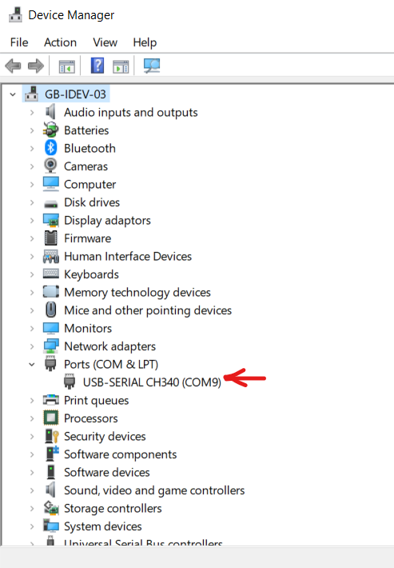  
   In this case it is COM9. Make a note of the serial port name.  
     
   **Important:** If you do not see that a COM Port has been added then maybe you do not have the CH340 driver installed on your system. Please follow this link for instructions on how to install the necessary driver: <https://learn.sparkfun.com/tutorials/how-to-install-ch340-drivers/all>
8. Now start TeraTerm and select “Setup” then “Serial Port”. You should pick the Port that corresponds to the one shown by Device Manager. The Speed is 460800. The other settings are as follows:  
   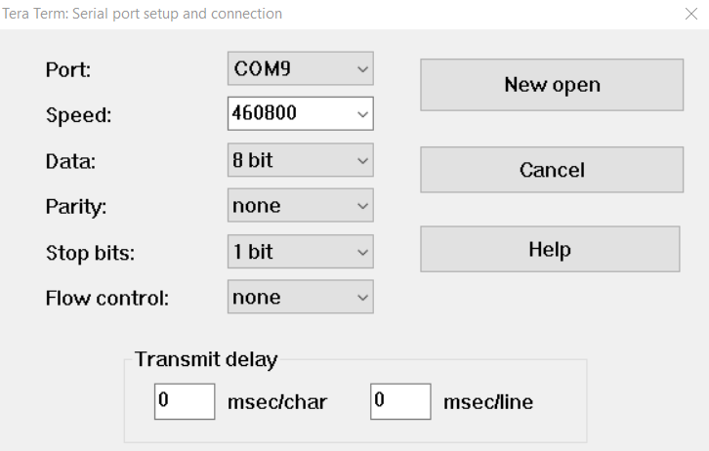
9. Now go to “Setup” then “Terminal” and select these settings. One setting of particular note is the New-line Transmit setting. This dictates what character(s) TeraTerm should send when you press Enter on your PC keyboard. “CR” seems to work best in my experience, as that is what CP/M is expecting.  
   Graphical user interface, application, Word

   Description automatically generated
10. Now go to “Setup” then “Font” then “Font”. It is best if you can pick a font that can display all 255 ASCII characters. I use one I found called “8514oem”:  
    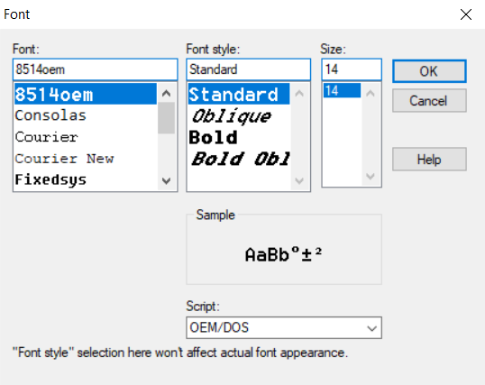  
    This is not essential, but will help you in some CP/M programs to see all of the characters properly.
11. Now press the “Reset” button on the Z80 Playground and you will see this:  
    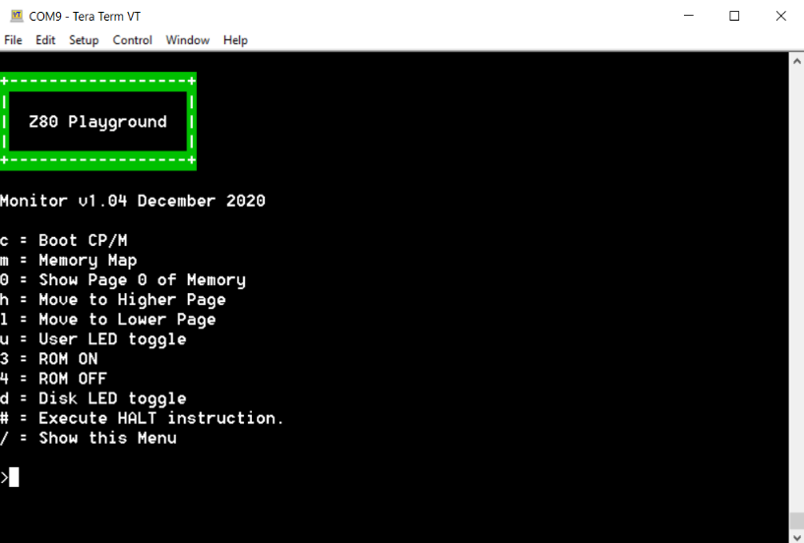
12. Yay! It’s all working. You will notice that the Green power LED is alight. Also the white ROM LED will be on too. The blue User LED does a quick set of 3 flashes to show all is good, and you’ll get some activity from the yellow Disk LED as well. You are now ready to go!
13. You may notice that there are two “jumper” switches in the top left corner of the board. The left one controls whether the ROM is Always On, or whether it can be Switched by software. The right one controls whether there is 32K or 16K of ROM available. The ROM lays over the top of the bottom-most region of the 64K RAM (unless the ROM is switched off). You can test this by pressing M for the memory map:  
    Timeline

    Description automatically generated  
    Here you can see that the RAM is taking up all 64K of address space, and the ROM is laying over the top of the first 32K. (Note that reading from a specific memory location will read from the top-most available layer, so ROM if it is switched on, otherwise from RAM. But writing to memory always writes to the RAM.)
14. Press “/” to go back to the first menu. You can now play around toggling the LEDs on and off if you like, with “U”, “D”, “3” and “4”.
15. Now let’s boot CP/M. Press “C”…  
    Text

    Description automatically generated  
    How lovely to see the “A>” prompt! As I’m sure you know, you can now type “DIR” and you are entering into the fun world of CP/M v2.2

I’ve included a few programs on various drives, e.g. type “H:” to go to drive H where you can find “The Hitchhiker’s Guide to the Galaxy”. Please note that these are all programs that I found on the Internet. I do not own them and I am not selling them, I have just included them as examples. For other programs that I have found and tested on the Z80 Playground please go to <https://8bitStack.co.uk>

Also, you may not realise this, but you are an early-adopter! You have in your hands one of the very first Z80 Playgrounds to be produced. I have never sold anything like this before, and I can well imagine that there could be some teething-problems. So, please contact me if you have any questions, problems or feedback: [john@8bitStack.co.uk](mailto:john@8bitStack.co.uk)

One other thing. If you have watched my videos you may have seen me pulling out the ROM while a program is running, or swapping over the jumper settings while the Z80 Playground is powered up. I don’t recommend that you do this. Please be careful to unplug the USB cable from your PC before adjusting anything. I learned this the hard way, and have dead chips to prove it!

Finally, I would love to help you get maximum enjoyment from this project. So I would appreciate it if you would get in touch and tell me how you are getting on with your Z80 Playground, and what you plan to do with it.

Thanks again,

John Squires

<https://8bitStack.co.uk>

(Norwich, UK, January 2021)